press release
(English translation)

CONFIDA AND ITALIAN EXHIBITION GROUP GO INTO PARTNERSHIP
TO DEVELOP THE VENDITALIA SHOW

Now at its 13th edition, the leading Italian and international vending industry’s trade show takes place every two years. 2024 recorded 22,300 trade visitors, 10% more than in 2022

Rimini, 2nd September 2024 – CONFIDA - Italian Vending Service Association – has chosen Italian Exhibition Group (IEG) as a strategic partner in the development of the “Venditalia” show, the vending industry’s main European exhibition. A new company has therefore been created to organise the future editions of Venditalia in Rimini and to oversee its product and international development.

Hence, as of spring 2026, Venditalia will be held in the halls of Rimini Expo Centre.

The agreement signed between Italian Exhibition Group and Venditalia, represented in person by President Ernesto Piloni, and with the unanimous approval of the Expo Centre’s Board and CONFIDA’s Shareholders, marks the start of the procedure for setting up a NewCo by autumn, 51% owned by IEG and 49% by Confida, which, as of 2026, will be responsible for the biennial organisation of “Venditalia - The vending expo”, the leading international vending service exhibition, a sector that deals with the automatic distribution of food, drinks and a growing number of products.

Founded in Genoa in 1998, “Venditalia” has continued to grow and attract more and more industry professionals. In 2004 it received the status of “international” event and this year, having reached its thirteenth edition, it achieved significant numbers: 32,000 square metres of exhibition space, 300 exhibitors (40% of which international, mainly from France, Spain, Germany, Poland, Portugal and the United Kingdom) and 22,300 trade visitors. In addition to offering the widest range of vending machines, products and services for vending, Venditalia also features a full programme of meetings and conferences that delve into the sector’s main challenges and opportunities.
These results and prominence are also supported by the fact that Italy is the vending industry’s European leader: in 2023, the sector recorded a total turnover of 2 billion euros (vending and Office Coffee Service), dispensed 5 billion consumptions, generated an employment spin-off of more than 33,000 people, included more than 3,000 companies and saw more than 830,000 vending machines installed (the largest fleet in Europe). Added to these numbers are other companies involved in the supply chain, such as food producers and manufacturers of accessories and technology. In regard to the latter, Italy holds supremacy: 70% of the machines produced are exported as are many vending machine accessories.
“We are extremely satisfied with this agreement,” commented IEG President Maurizio Ermeti. “It will allow us to stage a new international event in Rimini, the sector’s most important in Europe. And we are proud that CONFIDA, an association linked to the Confcommercio world and a leader in the sector, has appreciated our expertise as trade show organisers and chosen us as a strategic partner with which to give continuity and a further opportunity to develop an event that is already a sector leader. In fact, IEG’s decision aims at developing “Venditalia – The Vending Expo” both at a national and international level. For this reason, a workgroup of people from IEG will be engaged in supporting the event’s historic team in order to deploy a series of evolutionary elements and new entries already at the 2026 edition by developing both the product and internationalisation aspects.”
“After several years of success and development,” commented Ernesto Piloni, President of Venditalia, “we stopped to think and, with the firm intention to continue Venditalia’s growth, we looked for a new partner to work with and IEG was the best possible choice due to the strategic prospects it offers. The synergy that has been created between us will be fundamental for continuing to consolidate Venditalia's importance in the markets that we already preside over, such as Italy and Europe, but it will also be particularly fundamental for debuting in new international markets in the future, thus giving even more visibility to the incredible technological and product innovations that the Italian and European vending sector offers.”

PRESS CONTACT ITALIAN EXHIBITION GROUP | media@iegexpo.it
head of corporate communication & media relation: Elisabetta Vitali|
press office manager: Marco Forcellini, Pier Francesco Bellini | international press office coordinator: Silvia Giorgi | press office coordinator: Luca Paganin | press office specialist: Nicoletta Evangelisti, Mirko Malgieri
Confida Press Office – SEC Newgate Italia
Teresa Baroni – teresa.baroni@secnewgate.it 340 760 8713
Martina Basile – martina.basile@secnewgate.it 338 9034914

CONFIDA
Established on 13 July 1979, CONFIDA is the only trade association on a national level to represent the different product sectors of the entire food and beverage vending industry. It is a member of Confcommercio - Imprese per l'Italia and, within the EU, is a partner of EVA (European Vending & Coffee Service Association).

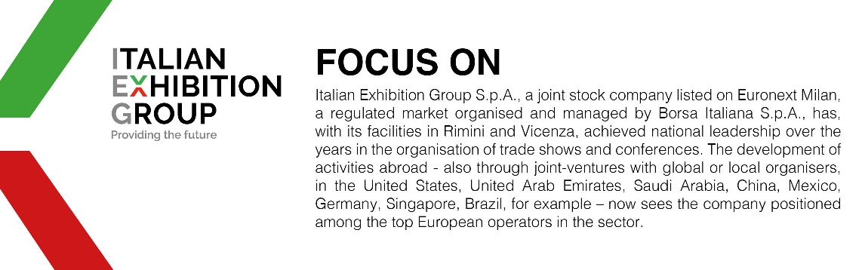

This press release contains forecast elements and estimates that reflect the management’s current opinions (“forward-looking statements”), particularly regarding future management performance, realization of investments, cash flow trends and the evolution of the financial structure. For their very nature, forward-looking statements have a component of risk and uncertainty, as they depend on the occurrence of future events. The effective results may differ (even significantly) from those announced, due to numerous factors, including, only by way of example: food service market and tourist flow trends in Italy, gold and jewellery market trends, green economy market trends; the evolution of raw material prices; general macroeconomic conditions; geopolitical factors and evolutions in the legislative framework. Moreover, the information contained in this release does not claim to be complete, and has not been verified by independent third parties. Forecasts, estimates and objectives contained herein are based on the information available to the Company as at the date of this release.

